|  |
| --- |
| **Ability Checks** |

|  |  |
| --- | --- |
| **Skills** | |
| **Ability Score** | **Associated Skills** |
| Strength | Athletics |
| Dexterity | Acrobatics, Sleight of Hand, Stealth |
| Constitution | N/A *(See Constitution table)* |
| Intelligence | Arcana, History, Investigation, Nature, Religion |
| Wisdom | Animal Handling, Insight, Medicine, Perception, Survival |
| Charisma | Deception, Intimidation, Performance, Persuasion |

|  |  |
| --- | --- |
| **Strength** | |
| Strength measures bodily power and athletic training. | |
| **Athletics 1** | |
| Automatic | Climb a wall with plenty of handholds or a secure, knotted rope or rope ladder; swim in relatively calm water; jump a number of feet horizontally equal to half of your Strength score, or your full Strength score with a 10 foot running start; leap into the air a number of feet equal to half of (3 + your Strength modifier), or the full amount with a 10 foot running start 2 |
| Easy | Climb a wall lacking an adequate amount of handholds, tread water in rough conditions, jump a few feet farther than you normally could; during a long jump, clear an obstacle such as a low-lying hedge or wall of height ≤a fourth of the jump’s distance |
| Moderate | Climb a rope dangling from a protrusion or overhang (i.e. lacking a vertical surface to brace against), swim in rough water or against a mild current |
| Hard | Climb a wall with very few handholds, catch yourself on a rope or other handhold in the middle or at the end of your jump, swim in violent water or against a strong current |
| Very Hard | Climb a slippery or sheer wall with little or no handholds, climb vertically along an overhang with adequate handholds, swim in stormy waters |
| **Feats of Strength • Other** | |
| Easy | Force open a stuck or broken door, break free from weak bindings, pull a stuck or wedged object loose |
| Moderate | Break through a wooden door reinforced with iron, hang on to a wagon while being dragged behind it |
| Hard | Break through a heavy locked or barred door, topple a stone statue |
| Very Hard | Break through a heavy, reinforced door such as a prison or armory door, hold a door shut against a room filling with water |
| **1: A PC can climb and swim under normal conditions without having to make a check; however, strenuous conditions may require that they pass an Athletics check. Each foot of movement during such a check costs an extra foot of movement, or an extra 2 feet if it is considered difficult terrain. Characters with climb and swim speeds ignore the extra costs associated with movement of this type.**  **Similarly, the horizontal and vertical distance a PC can jump without having to make a check is determined by their Strength score and modifier respectively. An Athletics check is generally only required when attempting to jump a distance farther than the amount calculate in the table above.**  **2: During a vertical jump a PC can extend their arms in order to achieve an extra distance equal to ½ of their height, which they can effectively add to their jump distance in order to attempt to grab on to a ledge or other handhold.** | |

|  |  |
| --- | --- |
| **Dexterity** | |
| Dexterity measures agility, reflexes, and balance. | |
| **Acrobatics** | |
| Easy | Walk across an icy surface, stay upright in a turbulent situation, land safely on difficult terrain |
| Moderate | Walk along a narrow ledge, swing from a chandelier and land on your feet |
| Hard | Cross a wildly swaying rope bridge |
| Very Hard | Walk across a tightrope, vault over or under an enemy (through their space) |
| **Sleight of Hand** | |
| Easy | Perform simple acts of legerdemain such as palming a coin-sized object |
| Contest  (vs. WIS) | Plant or steal an object on or from a target, conceal an object on your person |
| **Stealth 1** | |
| Contest  (vs. WIS) | Conceal yourself from enemies, sneak past unsuspecting targets, slip away while others are distracted |
| **Pick Lock 2 • Disarm Trap 2 • Other** | |
| Easy | Pick a simple lock, jam a simple trap, perform a task requiring particularly dexterous hands 3 |
| Moderate | Pick a typical lock, escape from tight rope bindings, securely restrain a prisoner |
| Hard | Pick an elaborate lock, disarm a trap of average complexity, steer a chariot around a tight corner |
| Very Hard | Pick a masterwork lock, disarm a complex trap, escape from locked masterwork manacles |
| **1: Generally, becoming hidden in combat requires being heavily obscured or under total cover, but ultimately the rules leave it up to your personal adjudication.**  **2: Proficiency with Thieves’ Tools allows a player to add their proficiency bonus to checks made to open locks and disarm traps.**  **3: Such as Operation ™.** | |

|  |  |
| --- | --- |
| **Constitution 1** | |
| Constitution measures health, stamina, and vital force. | |
| **Concentration** | |
| Easy | Distracting environmental stimuli such as a wave crashing over the deck of a storm-tossed ship |
| Variable  max(10,x) | After taking damage make a Constitution Saving throw with a DC of either 10 or half of the damage taken, whichever is higher. |
| **Forced March 2** | |
| Variable  (DC 10 + x) | At the end of each hour a PC must make a Constitution saving throw with a DC equal to 10 + the number of hours traveled past 8. On a failed throw the PC advances one level of exhaustion. |
| **Air** | |
| A PC can hold their breath for a number of minutes equal to 1 + their Constitution modifier (minimum 30 seconds). When out of breath, a PC can survive for a number of rounds equal to their Constitution modifier before they drop to 0 hit points and begin to die. | |
| **Food** | |
| A PC must eat one pound of food per day in order to subsist. They can go without food for a number of days equal to 3 + their Constitution modifier (minimum 1) before they begin to starve. This day count is reset when the PC eats their fill for a day; otherwise, the PC advances one level of exhaustion at the end of each day beyond their limit. | |
| **Water 3** | |
| Automatic | A PC drinking less than half the amount of water they require during the day advances one level of exhaustion at the end of the day, or two levels if they are already suffering from exhaustion. |
| Moderate | A PC drinking more than half the amount of water they require during the day but less than the full amount must succeed on a Constitution saving throw or advance one level of exhaustion, or two levels if they are already suffering from exhaustion. |
| **1: Constitution represents a largely passive set of ‘skills’ which have more to do with enduring than performing a specific action the PC can become proficient in. Therefore Constitution checks are more uncommon than other ability checks and are usually made without adding a proficiency bonus, although situational bonuses may still apply. NOTE: An ability check is different from a saving throw; players can be proficient at Constitution saving throws.**  **2: A PC can only travel for eight hours a day before they risk becoming exhausted.**  **3: A PC requires one gallon of water per day, or two if the climate is harsh.** | |

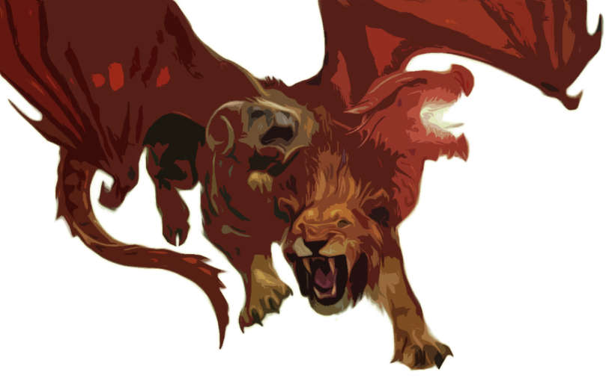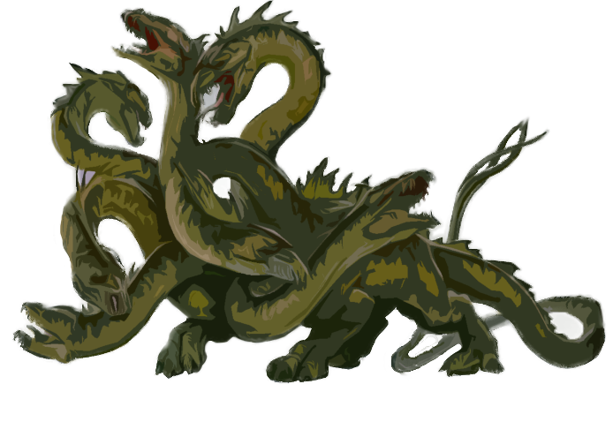

|  |  |
| --- | --- |
| **Typical Difficulty Classes** | |
| **Task Difficulty** | **DC** |
| Trivial | 5 |
| Easy | 10 |
| Moderate | 15 |
| Hard | 20 |
| Very Hard | 25 |
| Nearly Impossible | 30 |

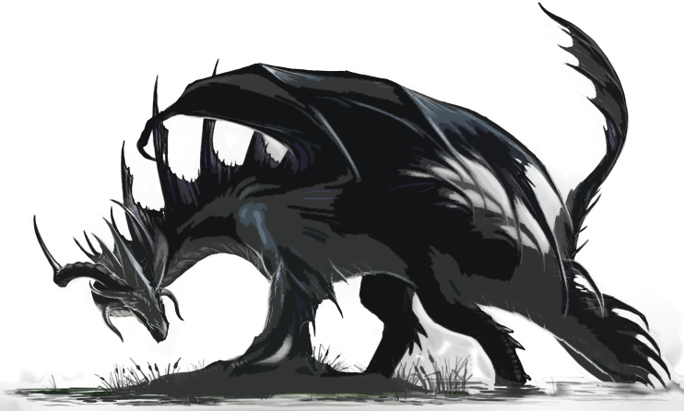

|  |  |
| --- | --- |
| **Intelligence** | |
| Intelligence measures mental acuity, accuracy  of recall, and the ability to reason. | |
| **Arcana • History • Nature • Religion** | |
| Easy | Recall widely known information; identify common people, places, objects, symbols, fauna, or flora |
| Moderate | Recall more obscure or specific information; identify uncommon people, places, objects, symbols, fauna, or flora |
| Hard | Recall truly esoteric or precise information; identify rare people, places, objects, symbols, fauna, or flora |
| Very Hard | Recall information that is known only by a privileged few; identify exceedingly rare people, places, objects, symbols, fauna, or flora |
| **Investigation • Other** | |
| Easy | Identify a particularly obvious trap or a secret or coded message left by a contact, communicate a simple idea with an intelligent creature you don’t share a language with, discover the true nature of a low-level illusion |
| Moderate | Identify a typical trap, determine time or cause of death of a recently deceased creature, estimate the material worth of an item, discover the true nature of a mid-level illusion |
| Hard | Identify a well-hidden trap, object, or area; forge a document or identify such a document, discover the true nature of a high-level illusion |
| Very Hard | Identify a magically-hidden trap, object, or area; discern the purpose and process of a complicated device or system; determine the integrity of a structure, construct, or formation and identify any exploitable weak points |

|  |  |
| --- | --- |
| **Wisdom** | |
| Wisdom measures perceptiveness, intuition, and attunement with the surrounding world. | |
| **Insight • Perception** | |
| Easy | Spot a prominent landmark or structure in the distance, hear the far-off sound of thunder signaling a coming storm, determine if a child is telling the truth |
| Moderate | Spot a natural-obscured object or feature, eavesdrop on a conversation in the next room, discern who among a cagey group is the leader, discern the intended message of a non-verbal communication |
| Hard | Spot a well-hidden object or feature, eavesdrop on a hushed conversation through a heavy door, guess at the enemy’s next action |
| Very Hard | Spot a nearly-invisible object or feature, read the lips of a creature you can see but not hear |
| Contest  (vs. CHA) | Determine if someone is lying or disguising themselves or their intentions |
| Contest  (vs. DEX) | Spot a creature attempting to hide, hear the movements of a hidden foe |
| **Survival** | |
| Easy | Follow a well-worn trail through a forest, follow the tracks of a creature through snow or mud, forage for a day’s worth of food in a plentiful area, navigate on a clear night |
| Moderate | Follow an abandoned or forgotten trail, track a creature through a forest, forage for a day’s worth of food in a sparse area, navigate on a cloudy night, predict an oncoming storm, identify the signs of nearby creatures |
| Hard | Track a creature over barren terrain, forage for a day’s worth of food in a harsh area, navigate through an alien area on a cloudy night, predict tomorrow’s weather |
| Very Hard | Track a creature after rainfall, navigate an alien area on a stormy night |
| **Animal Handling • Medicine • Other** | |
| Easy | Calm a domesticated animal, stabilize a dying creature outside of combat, diagnose a common ailment |
| Moderate | Calm a wild but otherwise peaceful animal, intuit an animal’s emotional state, set a broken bone, perform a complex maneuver while mounted, stabilize a dying creature in the middle of combat, diagnose an uncommon ailment |
| Hard | Intuit a hostile animal’s next action, control an untrained mount, diagnose a rare ailment |
| Very Hard | Calm a dangerous wild animal, diagnose magical and divine ailments |

|  |  |
| --- | --- |
| **Charisma** | |
| Charisma measures force of personality, persuasiveness, personal magnetism, social  influence, and physical attractiveness. | |
| **Deception** | |
| **Contest**  **(vs. WIS)** | Fast-talk or con someone, adopt a disguise or impersonate another creature, tell a convincing lie or otherwise hide your true intentions |
| **Intimidation** | |
| Easy | Scare a spineless noble in to handing over their coin purse |
| Moderate | Pry information out of an uncooperative prisoner, convince street thugs to back down from a confrontation |
| Hard | Advise a guard that it might be best to look the other way this time around, coerce an official in to signing a document |
| Very Hard | Frighten a creature larger than you, causing it to flee; stop an agitated mob in their tracks |
| **Performance** | |
| Easy | Routine performance such as telling a story in a tavern or around a campfire |
| Moderate | Professional performance such as an inspiring speech or an impressive musical display which may attract the attention of a local troupe and lead to regional fame |
| Hard | Memorable performance which may attract the attention of a local patron and lead to national fame |
| Very Hard | Extraordinary performance which may attract the attention of distant patrons and even extraplanar beings |
| **Persuasion** | |
| Easy | Convince the mayor to allow your party to help, calm a distraught person |
| Moderate | Persuade a group of highway thieves to leave in peace, convince a friendly acquaintance that you know best |
| Hard | Convince a chamberlain to let your party see the king, inspire or rally a crown of townsfolk, negotiate a peace between warring tribes |
| Very Hard | Convince a sphinx that you are worthy of the secrets it guards, assure a dragon you’re worth more alive than dead |

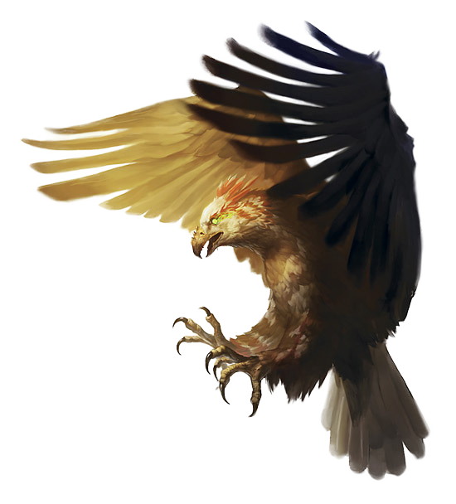

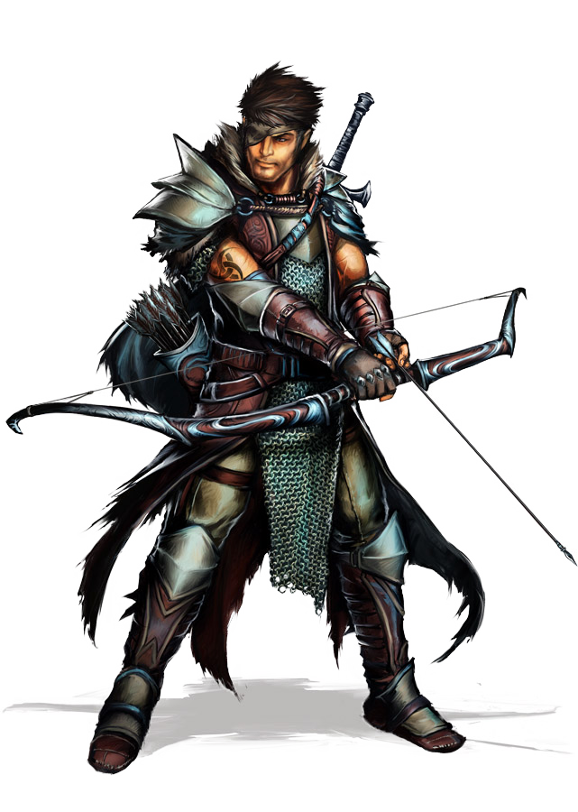

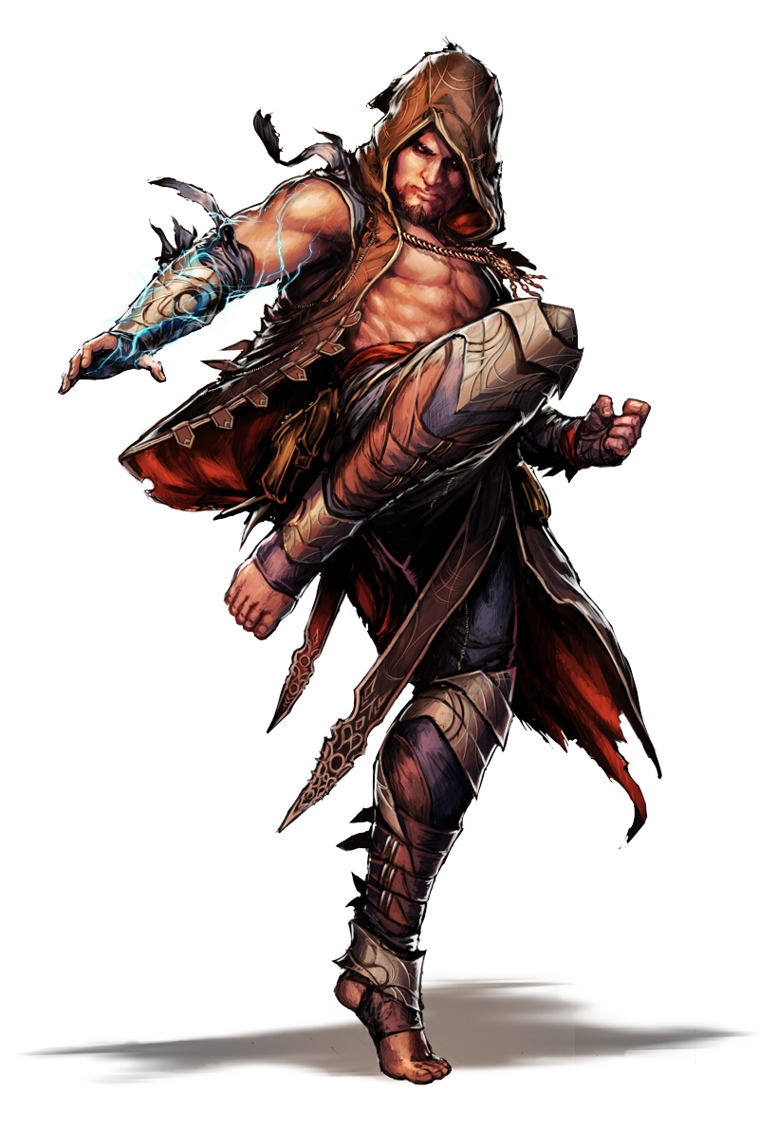

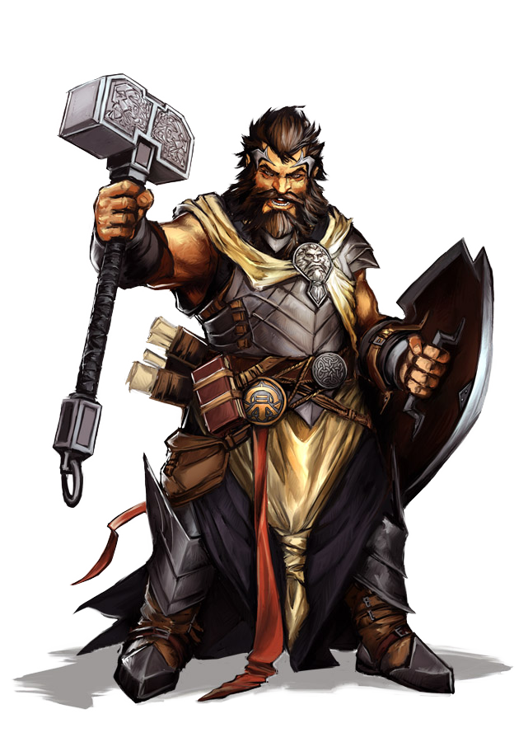



|  |  |  |
| --- | --- | --- |
| Character Advancement | | |
| Lv. | **Exp. 1** | **Prof.**  **Bonus** |
| 1 | 0 | +2 |
| 2 | 300 | +2 |
| 3 | 900 | +2 |
| 4 | 2,700 | +2 |
| 5 | 6,500 | +3 |
| 6 | 14,000 | +3 |
| 7 | 23,000 | +3 |
| 8 | 34,000 | +3 |
| 9 | 48,000 | +4 |
| 10 | 64,000 | +4 |
| 11 | 85,000 | +4 |
| 12 | 100,000 | +4 |
| 13 | 120,000 | +5 |
| 14 | 140,000 | +5 |
| 15 | 165,000 | +5 |
| 16 | 195,000 | +5 |
| 17 | 225,000 | +6 |
| 18 | 265,000 | +6 |
| 19 | 305,000 | +6 |
| 20 | 355,000 | +6 |
| 1: Experience points are cumulative. | | |

|  |
| --- |
| **Resting** |
| **Short Rest** |
| A period of downtime lasting at least one hour, during which time you can do nothing more strenuous than eating, drinking, reading, or tending to wounds.  The following effects resolve at the end of a Short Rest:   * You regain the use of abilities, features, and resources that are refreshed by taking a Short Rest. * You are allowed to expend one of your accumulated Hit Die by rolling a die of the corresponding type. You regain hit points equal to the rolled value + your Constitution modifier. Afterwards, you may choose to spend another Hit Die. |
| **Long Rest** |
| A period of extended downtime lasting at least eight hours, during which time you must either sleep or perform only light activities such as talking, eating, or standing watch. These activities can occupy no more than 2 hours of your Long Rest. Performing more than an hour of strenuous activity such as walking or fighting will also interupt your Long Rest. You may only benefit from one Long Rest in a 24-hour period and you must begin the rest with at least one hit point.  The following effects resolve at the end of a Long Rest:   * You regain the use of abilities, features, and resources that are refreshed by taking a Long Rest. * You regain all of your lost hit points unless otherwise indicated. * You regain a number of Hit Die equal to up half of your total possible Hit Die. |

|  |  |
| --- | --- |
| **Damage and Dying** | |
| Unconscious | When you are reduced to zero hit points you fall unconscious. There are no negative hit point values. |
| Death Saving Throws | Whenever you start your turn with zero hit points you must make a death saving throw, not to be confused with a Constitution saving throw. On a roll of 10 or higher, you succeed. Otherwise, you fail. On your third success you become stable while on your third failure you die. These results need not be consecutive. On a roll of 1 you suffer two failures while on a roll of 20 become stable and gain one hit point. |
| Damage at zero Hit Points | If you take any damage while at zero hit points you suffer a death saving throw failure. If this damage is from a critical hit you instead suffer two failures. If this damage is greater than or equal to your hit point maximum you suffer instant death. |

|  |  |
| --- | --- |
| Conditions & States | |
| Blinded | Automatically fail any check requiring sight. Disadvantage on attack rolls. Attackers have advantage. |
| Charmed | Cannot attack the charmer or target them with harmful abilities or effects. Charmer has advantage on interacting socially with the charmed creature. |
| Deafened | Automatically fail any ability check that requires hearing. |
| Dead | You are dead. Sorry. You’ve got a couple options: activate plot armor, become a servant of the Raven Queen, come back to life through any number of different spells (my favorite is reincarnate!), roll a new character. |
| Exhausted | See Exhaustion table |
| Falling | At the end of a fall a creature takes 1d6 bludgeoning damage for every 10 feet they fell (max 20d6) . A creature who takes damage this way is knocked prone. |
| Frightened | Disadvantage on ability checks and attack rolls while the source of the fear is within sight. Cannot willingly move towards the source of the fear. |
| Grappled | Speed reduced to 0. Ends when grappler is incapacitated, is no longer within reach, or fails a skill contest. |
| Incapacitated | Cannot take actions or reactions. |
| Incorporeal | Resistance against nonmagical damage; targets are resistant against nonmagical damage from an incorporeal source. Can move through objects and other creatures but must end movement in an empty space. |
| Invisible | Considered heavily obscured for the purposes of hiding. Advantage on attack rolls. Attackers have disadvantage. |
| Paralyzed | Incapacitated and cannot move or speak. Automatically fail Strength and Dexterity saving throws. Attackers have advantage and any attack that hits and is made from within 5 feet is a crit. |
| Petrified | Weight increases by a factor of ten and no longer age. Incapacitated cannot move or speak, and unaware of surroundings. Automatically fail Strength and Dexterity saving throws. Attackers have advantage. Resistance to all damage. Any poison or disease already afflicting the target is suspended and the target become immune to poison and disease. |
| Poisoned | Disadvantage on attack rolls and ability checks. |
| Prone | Only movement option is crawl until standing up. Disadvantage on attack rolls. Attackers within 5 feet have advantage, otherwise they have disadvantage. Can stand up by using half of your total movement speed. |
| Restrained | Speed reduced to 0. Disadvantage on attack rolls and Dexterity saving throws. Attackers have advantage. |
| Squeezing | Considered one size category smaller for the purposes of movement through tight areas. Every foot of movement costs an extra foot. Disadvantage on attack rolls and Dexterity saving throws. Attackers have advantage. |
| Stable | 0 hit points and unconscious but don’t need to make Death saving throws. Any damage taken causes causes the creature to stop being stable and to resume making Death saving throws. The Stable condition ends when the creature is no longer at 0 hit points. If still at 0 hit points after 1d4 hours, regain 1 hit point. |
| Stunned | Incapacitated and cannot move. Ability to speak is impaired but not lost. Automatically fail Strength and Dexterity saving throws. Attacks have advantage. |
| Unconscious | Incapacitated, cannot move or speak, and unaware of surroundings. Drop any held items and fall prone. Automatically fail Strength and Dexterity saving throws. Attackers have advantage and any attack that hits from within 5 feet is a crit. |

|  |  |  |  |  |
| --- | --- | --- | --- | --- |
| **Traveling 1** | | | | |
| **Travel Pace** | **Distance Traveled per…** | | | **Effect** |
| **Minute** | **Hour** | **Day** |
| Slow | 200 ft. | 2 miles | 18 miles | Able to stealth |
| Normal | 300 ft. | 3 miles | 24 miles | — |
| Fast | 400 ft. | 4 miles | 30 miles | -5 penalty to Passive Perception |
| **1: A group of adventurers can travel for eight hours each day. Use Passive Perception to determine if threats are noticed.** | | | | |

|  |  |  |
| --- | --- | --- |
| **Donning and Doffing Armor** | | |
| **Category** | **Don** | **Doff** |
| Light | 1 min | 1 min |
| Medium | 5 min | 1 min |
| Heavy | 10 min | 5 min |
| Shield | 1 action | 1 action |

|  |  |
| --- | --- |
| **Exhaustion 1** | |
| **Lv.** | **Effect** |
| 1 | Disadvantage on ability checks |
| 2 | Speed halved |
| 3 | Disadvantage on attack rolls and saving throws |
| 4 | Hit point maximum halved |
| 5 | Speed reduced to 0 |
| 6 | Death |
| **1: The effects of exhaustion are cumulative. At the end of a long rest if a creature has had food or drink it decreases its level of Exhaustion by one**. | |

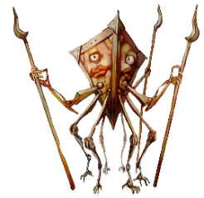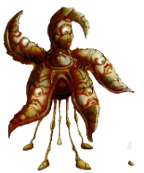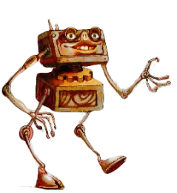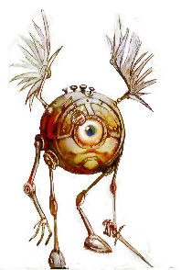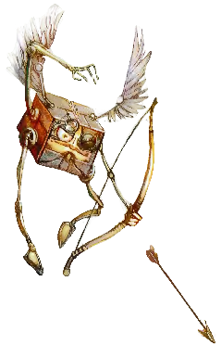

|  |  |
| --- | --- |
| **Cover** | |
| **Degree** | **Effect** |
| Half Cover | Grants +2 bonus to AC and Dexterity saving throws. |
| Three-quarters Cover | Grants +5 bonus to AC and Dexterity saving throws. |
| Total Cover | Cannot be targeted directly by attacks or spells, although area of effect spells and abilities are still effective. |

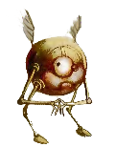

|  |  |  |  |  |
| --- | --- | --- | --- | --- |
| Weapons | | | | |
| Weapon | Cost | Damage | Weight | **Properties** |
| Simple Melee Weapons | | | | |
| Club | 1 sp | 1d4 Bludgeoning | 2 lb. | Light |
| Dagger | 2 gp | 1d4 Piercing | 1 lb. | Finesse, Light, Thrown (20/60) |
| Greatclub | 2 sp | 1d8 Bludgeoning | 10 lb. | Two-handed |
| Handaxe | 5 gp | 1d6 Slashing | 2 lb. | Light, Thrown(20/60) |
| Javelin | 5 sp | 1d6 Piercing | 2 lb. | Thrown(30/120) |
| Light Hammer | 2 gp | 1d4 Bludgeoning | 2 lb. | Light, Thrown(20/60) |
| Mace | 5 gp | 1d6 Bludgeoning | 4 lb | — |
| Quarterstaff | 2 sp | 1d6 Bludgeoning | 4 lb. | Versatile(1d8) |
| Sickle | 1 gp | 1d4 Slashing | 2 lb. | Light |
| Spear | 1 gp | 1d6 Piercing | 3 lb. | Thrown(20/60), Versatile(1d8) |
| Unarmed Strike | — | 1 Bludgeoning | — | — |
| Simple Ranged Weapons | | | | |
| Crossbow, Light | 25 gp | 1d8 Piercing | 5 lb. | Ammunition(80/320), Loading, Two-handed |
| Dart | 5 cp | 1d4 Piercing | ¼ lb. | Finesse, Thrown(20/60) |
| Shortbow | 25 gp | 1d6 Piercing | 2 lb. | Ammunition(80/320), Two-Handed |
| Sling | 1 sp | 1d4 Bludgeoning | — | Ammunition(30/120) |
| Martial Melee Weapons | | | | |
| Battleaxe | 10 gp | 1d8 Slashing | 4 lb. | Versatile(1d10) |
| Flail | 10 gp | 1d8 Bludgeoning | 2 lb. | — |
| Glaive | 20 gp | 1d10 Slashing | 6 lb. | Heavy, Reach, Two-handed |
| Greataxe | 30 gp | 1d12 Slashing | 7 lb. | Heavy, Two-handed |
| Greatsword | 50 gp | 2d6 Slashing | 6 lb. | Heavy, Two-handed |
| Halberd | 20 gp | 1d10 Slashing | 6 lb. | Heavy, Reach, Two-handed |
| Lance | 10 gp | 1d12 Piercing | 6 lb. | Reach, Special |
| Longsword | 15 gp | 1d8 Slashing | 3 lb. | Versatile(1d10) |
| Maul | 10 gp | 2d6 Bludgeoning | 10 lb. | Heavy, Two-handed |
| Morningstar | 15 gp | 1d8 Piercing | 4 lb. | — |
| Pike | 5 gp | 1d10 Piercing | 18 lb. | Heavy, Reach, Two-handed |
| Rapier | 25 gp | 1d8 Piercing | 2 lb. | Finesse |
| Scimitar | 25 gp | 1d6 Slashing | 3 lb. | Finesse, Light |
| Shortsword | 10 gp | 1d6 Piercing | 2 lb. | Finesse, Light |
| Trident | 5 gp | 1d6 Piercing | 4 lb. | Thrown(20/60), Versatile(1d8) |
| War Pick | 5 gp | 1d8 Piercing | 2 lb. | — |
| Warhammer | 15 gp | 1d8 Bludgeoning | 2 lb. | Versatile(1d10) |
| Whip | 2 gp | 1d4 Slashing | 3 lb. | Finesse, Reach |
| Martial Ranged Weapons | | | | |
| Blowgun | 10 gp | 1 Piercing | 1 lb. | Ammunition(25/100), Loading |
| Crossbow, hand | 75 gp | 1d6 Piercing | 3 lb. | Ammunition(30.120), light, loading |
| Crossbow, heavy | 50 gp | 1d10 Piercing | 18 lb. | Ammunition(100/400), Heavy, Loading, Two-handed |
| Longbow | 50 gp | 1d10 Piercing | 2 lb. | Ammunition(150/600), Heavy, Two-handed |
| Net | 1 gp | — | 3 lb. | Special, Thrown(5/15) |

|  |  |  |  |  |
| --- | --- | --- | --- | --- |
| Armor & Shields | | | | |
| Armor | Cost | Armor Class | Weight | **Properties** |
| Light Armor | | | | |
| Padded | 5 gp | 11 + Dex Mod | 8 lb. | Disadvantage(Stealth) |
| Leather | 10 gp | 11 + Dex Mod | 10 lb. | — |
| Studded Leather | 45 gp | 12 + Dex Mod | 13 lb. | — |
| Medium Armor | | | | |
| Hide | 10 gp | 12 + Dex Mod (Max 2) | 12 lb. | — |
| Chain Shirt | 50 gp | 13 + Dex Mod (Max 2) | 20 lb. | — |
| Scale Mail | 50 gp | 14 + Dex Mod (Max 2) | 45 lb. | Disadvantage(Stealth) |
| Breastplate | 400 gp | 14 + Dex Mod (Max 2) | 20 lb. | — |
| Half Plate | 750 gp | 15 + Dex Mod (Mas 2) | 40 lb. | Disadvantage(Stealth) |
| Heavy Armor | | | | |
| Ring Mail | 30 gp | 14 | 40 lb. | Disadvantage(Stealth) |
| Chain Mail | 75 gp | 16 | 55 lb. | Disadvantage(Stealth), Strength(13) |
| Splint | 200 gp | 17 | 60 lb. | Disadvantage(Stealth), Strength(15) |
| Plate | 1500 gp | 18 | 65 lb. | Disadvantage(Stealth), Strength(15) |
| Shield | | | | |
| Shield | 10 gp | +2 | 6 lb. | — |

|  |  |
| --- | --- |
| **Services** | |
| **Service** | **Pay** |
| Coach Cab | |
| Between Towns | 3 cp/mile |
| Within a City | 1 cp |
| Hireling | |
| Skilled | 2 gp/day |
| Unskilled | 2 sp/day |
| Messenger | 2 cp/mile |
| Road/Gate Toll | 1 cp |
| Ship’s Passage | 1 sp/mile |
| First Level spell 1 | 10-30 gp + components |
| Second Level spell 1 | 30-50 gp + components |
| Third+ Level Spell 2 | How much ya got? 3 |
| **1: First and second level spellscasting services are easy enough to find in a decently sized city or town.**  **2: Third level and higher spells are much more rare and can only be found with any amount of regularity in a large city, perhaps home to a University or Temple.**  **3: Often times a spellcaster might ask for a service rather than monetary payment.** | |

|  |  |
| --- | --- |
| **Lifestyle Expenses** | |
| **Lifestyle** | **Price/Day** |
| Wretched | — |
| Squalid | 1 sp |
| Poor | 2 sp |
| Modest | 1 gp |
| Comfortable | 2 gp |
| Wealthy | 4 gp |
| Aristocratic | 10 gp minimum |

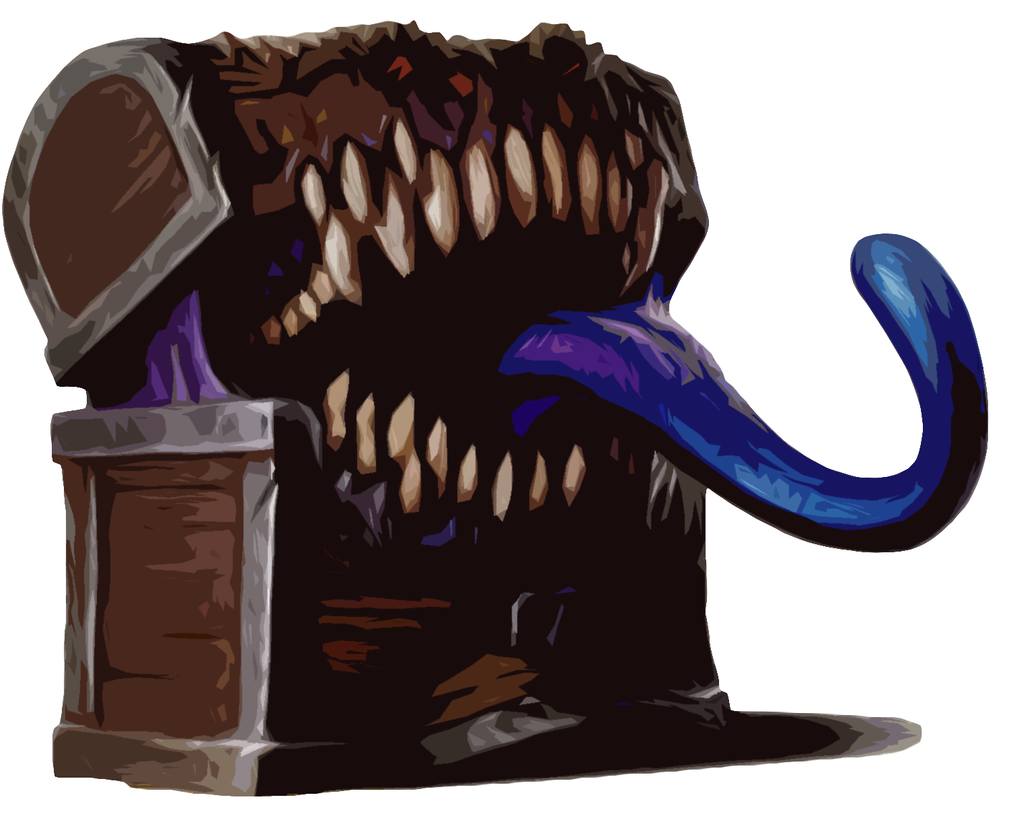

|  |
| --- |
| **Monster Statistics** |

|  |
| --- |
| **Encounter Building** |
| You can use this process after you’ve already designed an encounter to determine its difficulty or you can use it to start an Encounter from scratch with a target difficulty in mind. |
| 1. Start by making a note of the Exp values that define the four difficulty categories for your group. For each adventurer in the party refer to the *Encounter Difficulty Exp per Character* table, noting the exp values for each character in each category. Then for each category add the exp values for each character in that category to determine the difficulty thresholds for encounters. |
| 1. Next, select each creature you want to include in your encounter. Add up their Exp Values, which can be found in their stat block next to their Challenge Rating, to get the encounter’s Exp Value. |
| 1. Adjust the encounter Exp Value by the multiplier found in the *Encounter Exp Multipliers* table according to the size of the adventuring party. |
| 1. Compare the adjusted encounter Exp Value with the difficulty thresholds you calculated in Step 1 to get an estimate of the encounter’s difficulty. Adjust the encounter accordingly. |

|  |  |  |  |  |
| --- | --- | --- | --- | --- |
| Encounter Difficulty Exp Per Character | | | | |
| Level | **Easy** | **Medium** | **Hard** | **Deadly** |
| 1 | 25 | 50 | 75 | 100 |
| 2 | 50 | 100 | 150 | 200 |
| 3 | 75 | 150 | 225 | 400 |
| 4 | 125 | 250 | 375 | 500 |
| 5 | 250 | 500 | 750 | 1,100 |
| 6 | 300 | 600 | 900 | 1,400 |
| 7 | 350 | 750 | 1,100 | 1,700 |
| 8 | 450 | 900 | 1,400 | 2,100 |
| 9 | 550 | 1,100 | 1,600 | 2,400 |
| 10 | 600 | 1,200 | 1,900 | 2,800 |
| 11 | 800 | 1,600 | 2,400 | 3,600 |
| 12 | 1,000 | 2,000 | 3,000 | 4,500 |
| 13 | 1,100 | 2,200 | 3,400 | 5,100 |
| 14 | 1,250 | 2,500 | 3,800 | 5,700 |
| 15 | 1,400 | 2,800 | 4,300 | 6,400 |
| 16 | 1,600 | 3,200 | 4,800 | 7,200 |
| 17 | 2,000 | 3,900 | 5,900 | 8,800 |
| 18 | 2,100 | 4,200 | 6,300 | 9,500 |
| 19 | 2,400 | 4,900 | 7,300 | 10,900 |
| 20 | 2,800 | 5,700 | 8,500 | 12,700 |

|  |  |  |
| --- | --- | --- |
| Proficiency & Exp Value by Challenge Rating | | |
| CR | **Proficiency Bonus** | **Exp Points Value** |
| 0 | 2 | 0 or 10 |
| 1/8 | 2 | 25 |
| 1/4 | 2 | 50 |
| 1/2 | 2 | 100 |
| 1 | 2 | 200 |
| 2 | 2 | 450 |
| 3 | 2 | 700 |
| 4 | 2 | 1,100 |
| 5 | 3 | 1,800 |
| 6 | 3 | 2,300 |
| 7 | 3 | 2,900 |
| 8 | 3 | 3,900 |
| 9 | 4 | 5,000 |
| 10 | 4 | 5,900 |
| 11 | 4 | 7,200 |
| 12 | 4 | 8,400 |
| 13 | 5 | 10,000 |
| 14 | 5 | 11,500 |
| 15 | 5 | 13,000 |
| 16 | 5 | 15,000 |
| 17 | 6 | 18,000 |
| 18 | 6 | 20,000 |
| 19 | 6 | 22,000 |
| 20 | 6 | 25,000 |
| 21 | 7 | 33,000 |
| 22 | 7 | 41,000 |
| 23 | 7 | 50,000 |
| 24 | 7 | 62,000 |
| 25 | 8 | 75,000 |
| 26 | 8 | 90,000 |
| 27 | 8 | 105,000 |
| 28 | 8 | 120,000 |
| 29 | 9 | 135,000 |
| 30 | 9 | 155,000 |

|  |  |  |  |  |  |
| --- | --- | --- | --- | --- | --- |
| **Encounter Exp Multipliers** | | | | | |
| **Number of Enemies** | **Exp Multiplier for Party size of…** | | | | |
| **1-2** | | **3-5** | | **6-8** |
| Single Enemy | **×** 1.5 | — | | **×** .5 | |
| Pair (2 Enemies) | **×** 2 | **×** 1.5 | | — | |
| Group (3-6 Enemies) | **×** 2.5 | **×** 2 | | **×** 1.5 | |
| Gang (7-10 Enemies) | **×** 3 | **×** 2.5 | | **×** 2 | |
| Mob (11-14 Enemies) | **×** 4 | **×** 3 | | **×** 2.5 | |
| Horde (15+ Enemies) | **×** 5 | **×** 4 | | **×** 3 | |

|  |  |  |  |
| --- | --- | --- | --- |
| Random Encounter Chances | | | |
| Area | **Roll 1d20…** | **Encounter on…** | **Examples** |
| Dangerous overworld area | Once per hour of travel. | 18-20(15%) or  19-20(10%) | Mordor, Underdark, Zombie-infested swamp |
| Once per 20 minutes of Rest during the day. |
| Once at night. |
| Uncivilized, unsettled, or unknown overworld area | Once during the day. | 17-20(20%) or  18-20(15%) | Dothraki Sea, American Frontier |
| Once at night. |
| Well-traveled overworld area | Once a day-night Cycle. | 20(5%) | A major highway/trade route |
| Structure or formation populated by hostiles | Once per 15 minutes of Rest or Idle. | 17-20(20%) or  18-20(15%) | Enemy encampments, creatures’ lairs |

|  |  |  |  |
| --- | --- | --- | --- |
| **Size Categories & Hit Points** | | | |
| **Size** | **Space** | **Hit Die(Avg. Hit Points/Die)** | **Examples** |
| Tiny | 2.5 by 2.5 ft. | d4(2.5) | Hawk, Imp, Rat, Sprite |
| Small | 5 by 5 ft. | d6(3.5 | Giant Rat, Goblin, Kobold |
| Medium | 5 by 5 ft. | d8(4.5) | Gnoll, Orc, Werewolf |
| Large | 10 by 10 ft. | d10(5.5) | Chimera, Hippogriff, Ogre |
| Huge | 15 by 15 ft. | d12(6.5) | Cyclops, Fire Giant, Treant |
| Gargantuan | 20+ by 20+ ft. | d20(10.5) | Ancient Dragon, Kraken |